**oNLINE MOVIE TICKET BOOKING SYSTEM**

**movie ticket booking platform**

**Project Abstract**

**Version 1.0**

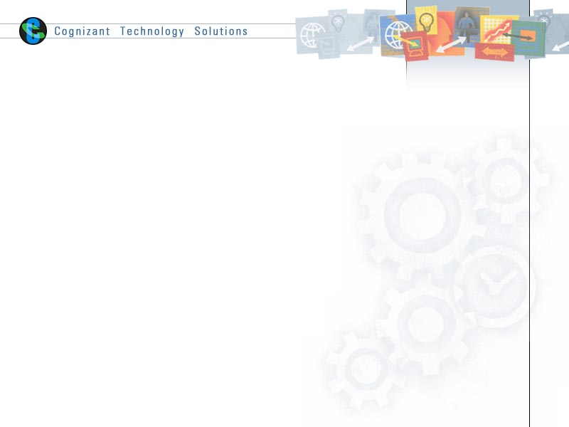

|  |  |  |  |
| --- | --- | --- | --- |
|  | Prepared By / Last Updated By | Reviewed by | Approved By |
| Name | Shubham Negi | <Trainer/ | <Trainer/Project Governance Representative/Cohort Mentor to fill> |
| Role | Programmer Analyst Trainee |  |  |
| Signature |  |  |  |
| Date |  |  |  |

Table of Contents

1.0 Purpose of this document 4

2.0 Business Case 4

3.0 Appendices 4

3.1 Glossary 4

3.2 Other 4

4.0 Terms & Conditions 5

5.0 Change Log 5

# Purpose of this document

Certainly! Here is an abstract containing the purpose of the Movie Ticket Booking System project:

* To streamline the process of purchasing movie tickets by providing a convenient and user-friendly platform.
* Allow users to effortlessly browse available movies, select preferred showtimes, and choose their desired seats from the comfort of their homes.
* Feature functionalities such as user registration, movie search, seat selection, payment processing, and ticket generation.
* Leverage modern technologies and secure transaction methods to ensure a seamless and reliable experience for users.
* Enhance the movie-going experience by eliminating the hassle of traditional ticket purchasing.
* Offer a comprehensive solution that caters to the needs of movie enthusiasts.
* Provide a personalized user experience by offering movie recommendations based on user preferences and past bookings.
* Facilitate the booking process through multiple payment options, including credit/debit cards, digital wallets, and net banking.
* Enable users to easily cancel or reschedule their bookings, with clear policies and procedures.

# Business Case

**Executive Summary**: Develop a user-friendly platform to streamline purchasing movie tickets, enhancing the movie-going experience.

**Problem Statement**: Current ticket purchasing methods are inconvenient, involving long queues and limited availability.

**Solution**: A digital platform for browsing movies, selecting showtimes, and booking tickets with ease.

**Objectives**:

* Simplify ticket booking
* Enhance user experience
* Increase sales for cinemas
* Ensure secure transactions

**Benefits**:

* User convenience
* Efficient booking process
* Personalized recommendations
* Multiple payment options
* Social media integration
* Loyalty programs

**Market Analysis**: Growing demand for online services and convenient solutions.

**Implementation Plan**:

* Requirements gathering
* Development
* Integration of additional features
* Testing and QA
* Deployment and maintenance

**Financial Analysis**: Initial development costs, ongoing operational expenses, and potential revenue from increased ticket sales and partnerships.

**Risk Analysis**: Technical challenges, market competition, and user adoption.

**Conclusion**: The system offers a valuable opportunity to transform the movie ticket purchasing experience, benefiting both users and cinemas.

# 

# Appendices

## Glossary

|  |  |
| --- | --- |
| **Acronyms** | **Definitions** |
| * 1. MEAN   2. DB   3. UI   4. UX | Angular.js, Express.js, Node.js  MongoDB, MS SQL Server  User Interface  User Experience |

## Other

* This section can include additional relevant information such as:
  + **Project Timeline:** A high-level overview of the project timeline, including key milestones and deadlines.
  + **Team Roles and Responsibilities:** A brief description of the roles and responsibilities of each team member.
  + **Project Risks and Mitigation Strategies:** An identification of potential risks and the strategies in place to mitigate them.
  + **Intellectual Property:** A statement regarding intellectual property rights and ownership.

This framework provides a starting point for each section of the document. Remember to adapt and expand upon these points as needed to create a comprehensive and informative document for the StudyHiveSync ed-tech platform.

# Terms & Conditions

***Disclaimer: Please do not circulate or distribute this document outside of Cognizant Network, We have a Zero Tolerance Policy. Kindly adhere to 100% Compliance at all times.***

# Change Log

*Please note that this table needs to be maintained even if a Configuration Management tool is used.*

|  |  |  |  |  |
| --- | --- | --- | --- | --- |
| Version Number | Changes made | | | |
| V<n.n> | *<If the change details are not explicitly documented in the table below, reference should be provided here>* | | | |
| Page no | Changed by | Effective date | Changes effected |
|  |  |  |  |
|  |  |  |  |
|  |  |  |  |
|  |  |  |  |